# Softplc

## Introduction

As explained in the introduction the PLC is a programmable controller. It is used to make some logic controls that automate the operation and functionality of certain processes.

Normally this is programmed right into the PLC itself. The pro is that it can work stand alone. The con is that the programming of a PLC is time consuming and you need to know everything about the specific PLC. Especially when you need it to interact with FT NavVision© it becomes quit a hassle.

## General

A PLC (programmable logic controller) is an electronic device with a microprocessor that, on the basis of its various inputs, controls its outputs. A good example is the Wago PLC that we use often with our system. To make it easier to use and also to extend the range to use it with, we developed a soft PLC for FT NavVision® . It is way beyond the scope of this manual to teach you how to program a PLC. That is knowledge that you need to have or that you need to acquire. The functionality is the same as any other PLC programming device.

## Basics

When you open Soft PLC for the first time you get an empty screen (see Figure 8‑1)

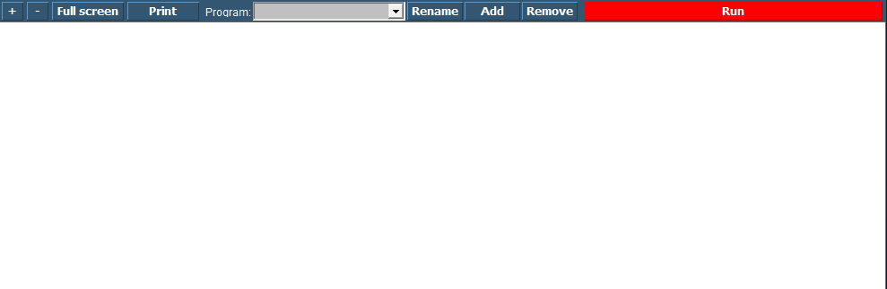

Figure 8‑1: Soft PLC

The following figures apply to the buttons on the screen:

|  |  |
| --- | --- |
| **Soft PLC Switch** | **Function** |
| +/- | Zoom in or out |
| Full Screen | Goto Fullscreen mode |
| Print | Print the Ladder Diagram |
| Program | Choose which PLC program you want to adjust by clicking the dropdown button |
| Rename | Rename the PLC program |
| Add | Add a new PLC program |
| Remove | Remove a PLC program |
| Run | Manually run or stop a specific PLC program |